# Electronic signatures

When you’re applying for one of our products or carrying out other activity on your account, we might send you an email asking you for an electronic signature.

If you’ve not received one of these before, you might be suspicious.

It’s a good idea to be on your guard against possible phishing scams - but HSBC does send out genuine messages asking you to sign documents using [echosign@echosign.com](mailto:echosign@echosign.com).

Here’s what to look out for.

## What will the email look like?

The sender of the email will appear in your inbox something like this:

**HSBC <**[**echosign@echosign.com**](mailto:echosign@echosign.com)**>**

This is a secure message powered by Adobe Sign/EchoSign and issued by HSBC. The email template might vary slightly, but you can expect a genuine message to look like this:

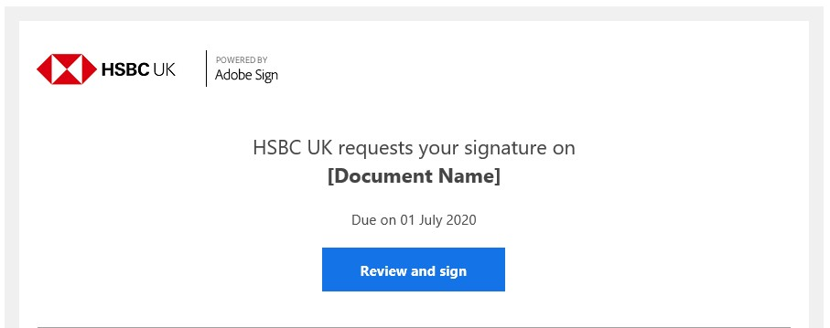The document name may vary depending on the form being sent out.

## What is an electronic signature?

An electronic signature, or e-signature, is a legal way to gain consent or approval on electronic forms or documents where it’s impractical to get a physical signature. Under no circumstances will we ask for security details such as your PIN, online banking codes or password.

## What is Adobe Sign?

Adobe Sign is a tool used by HSBC. It allows us to securely send documents and collect your signature in a convenient, quick way rather than conventional paper-based methods.

## Why is the email from EchoSign?

EchoSign, as written and seen above, is owned by Adobe Sign. It’s the technology that allows you to provide an electronic signature.

## How do I use Adobe Sign?

Simply open the link provided in the email and follow instructions. This can be done by using a mobile phone, tablet or computer.

## ****Useful information****

If you're expecting an email from us, remember to check your junk folder in case it's landed there.

The link on the form will redirect you to the document. We’ll send a one-time password to your phone to allow you to access the document.

We use the contact details that we hold for you on our system. Please make sure both your email address and mobile number are up-to-date so you can view the form.